**Draft**

**VSMAPP Project Plan**

**Draft version of VSMAP Project Plan**

**Overview:**

Value Stream Mapping is a method of creating a “One page picture” of all the processes that occur in a company, from the time a customer places an order for a product, until the customer has received that product in their facility.

The goal is to depict material and information flows across and throughout all Value-Adding Processes required to produce and ship the product to the customer. Value Stream Maps document all of the processes used to produce and ship a product, both Value-Adding and Non-Value-Adding (Waste) processes. During the Value Stream Mapping, business and manufacturing waste that occur in the processes can be easily identified.

Once the **Current State Value Stream Mapping** (Appendix B) is created, it becomes the baseline for improvements and for the creation of a **Future State Value Stream Mapping.**

Different icons/symbols are used to map a process.

**Design Features:**

**Symbols:**

Symbols will be divided into 5 categories as shown in Appendix A1. Symbols provided in the Appendix are for reference only, designer needs to create these symbols in higher quality.

A menu will be provided which will show 5 categories of symbols. When user taps the symbol for long time, it should show a description of the symbol, also provided in the **Appendix A** (will be updated).

User can also attach customized symbols, taken by iPad camera, or from iPad pictures. User can name these symbols and used in other reports too.

**Functional Requirements:**

* User can drag and drop symbols.
* User can resize symbol.
* User can delete a symbol.
* User can change color of the symbol.
* User can copy and paste a symbol.
* User can also write text inside some specific symbols which will be used in mathematical calculations.
* User can write on the report area.

**Reports features:**

* A Value Stream Map has 4 parts. Description of the process that user is mapping (optional). Current Value Stream Map, and Future Value Stream Map. User will first draw the current value stream map and than future value stream map. Last part will be improvements in the process; this will depends on the mathematical calculation summary done automatically (based in mathematical values provided by the user during mapping process) after the mapping of current state and future state.
* A template will be provided to user where some of the icons will be placed already. Another option will also be available where user will get only a plan sheet and can select the symbols independently.
* Some icons will be connected to each other based on their relationship. It means when user drag and drop a symbol to a map, and if that symbol is suppose to be attached with a specific symbol (already in the map) than it should automatically attach itself with that symbol.
* If a symbol is not suppose to attach with some specific symbols, than app should give a signal when user try to attach both symbols.
* User can (re)name/delete the report.
* User can select the format of the report. (first description, than current state, than future state, than summary of mathematical calculations, or in any other order of these 4 parts).
* User can save a report in the iPad in such a way that if he deletes/updates the app, he should be able to retrieve the report.
* User can email a report.
* User can open a report emailed from another app user.
* User can edit a report send from another user.
* User can see list of existing reports created.
* User can reedit the existing reports.

**Mathematical Calculation:**

Some simple mathematical calculations will also be done automatically based on the numeric values provided during the mapping process. The user will provide these values. When user insert some specific symbol, such as “Data Box” symbol (more detail will be provided later on).

**Builds detail & time line:**

**Total days required: 90**

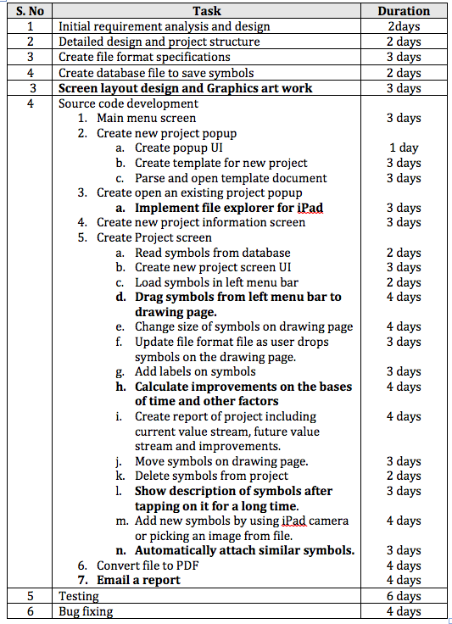

**Screens Shots (Draft):**

**Splash Screen**

Splash screen will appear at the time of launch of the app.

**Main Menu (Dashboard)**

Main menu screen will display a list of options available to the user. These options include ‘Create New Project’. ‘Open an existing project’, ‘Settings’, ’About’.

**Value Stream**

Create New Project

Open an existing project

About

**Create New Project**

appear above Main Menu screen. This screen contains two options.

**Value Stream Map**

Create New Project

Open an existing project

Settings

About

Create project from template

Create blank project

This screen appears when user taps on ‘Create New Project’ option on Main menu screen. This screen is actually a popup, which will

1) Create Blank Project,

2) Create project from template.

**Open an existing project**

This screen appears when user taps on ‘Open an existing project’ option on Main menu screen. This option opens a File explorer where user can locate his desired file to open.

**Project Start screen.**

This screen opens when user taps on any of the options on ‘Create New Project’ screen. User may add following information on Project Start screen.

1. Value Stream name
2. Project Team
3. Value Stream description

User taps on Next button to go to Project screen.

**Process Screen**

Process screen has two parts. Left side consists of a stencil. This stencil contains a number or different diagrams (symbols) which user can chose while creating a value stream map. Right side of this screen contains a tabbed view in which user can add project information. User can drag any diagram from stencil and place it in right side view. User will be provided with following tabs related to different phases of Value Stream Mapping.

1. Value Stream Description
2. Current Value stream
3. Future value stream
4. Compare
5. Improvement Steps

**sValue Stream Description**

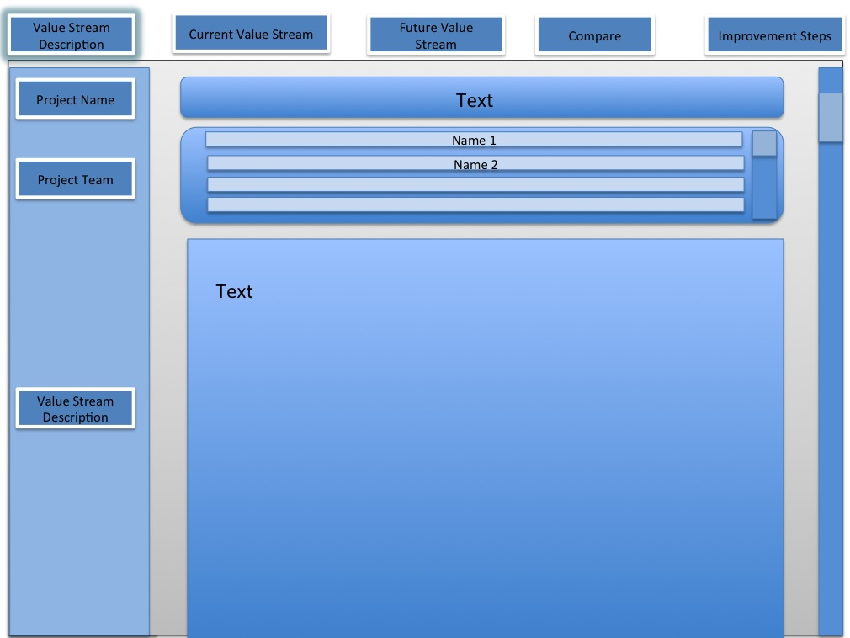

**Current Value Stream / Future Value Stream**

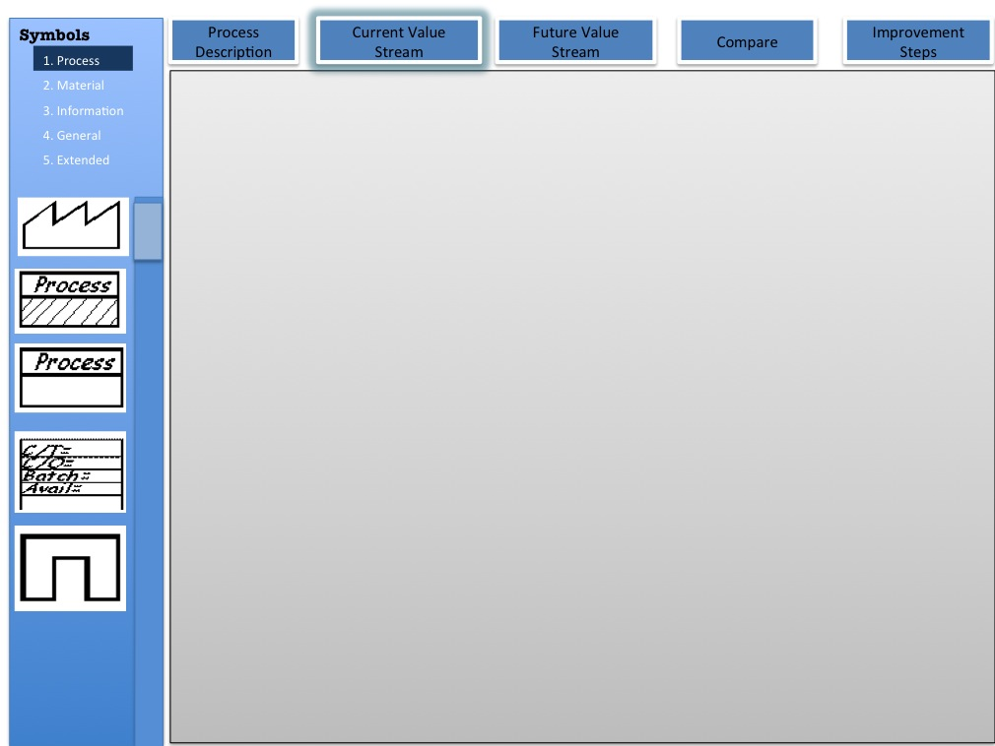

**Compare (Comparison of current and future value streams)**

User will see both Current value stream and future value stream on this page. Each value stream will take half of the page and user will be able to scroll both streams in any direction.

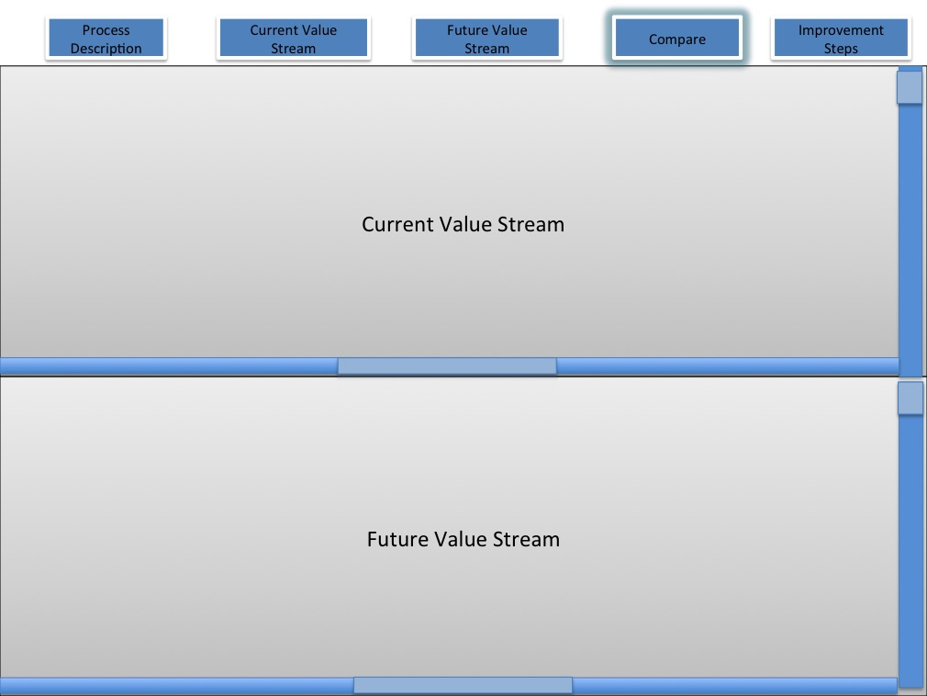

**Future Steps**

Future Steps tab will show all steps required in order to move from current value stream map to future value stream map.

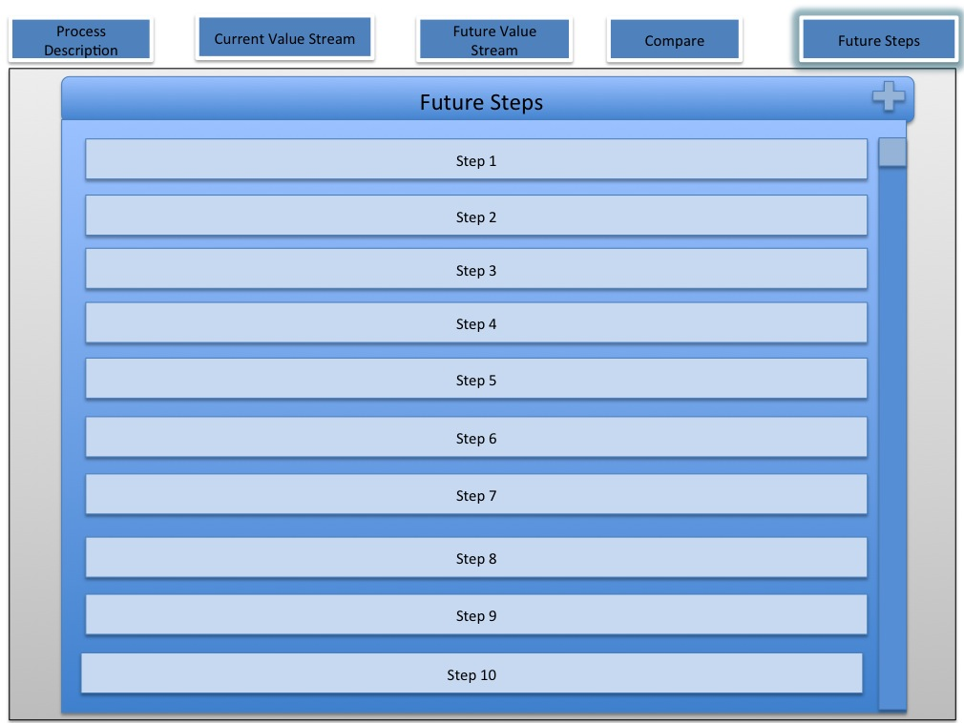

**Appendix A.**

|  |  |  |  |  |
| --- | --- | --- | --- | --- |
| **1. Process Symbols** | | | | |
| **No.** | **Symbol Name** | **Symbol** | **Explanation** | **Extra Requirements** | |
| 1.1 | Customer /Supplier |  | This icon represents the **Supplier** when in the upper left, the usual starting point for material flow. The **customer** is represented when placed in the upper right, the usual end point for material flow. |  | |
| 1.2 | Dedicated Process |  | The dedicated process icon is a process, operation, machine or department, through which material flows. Typically, to avoid unwieldy mapping of every single processing step, it represents one department with a continuous, internal fixed flow path. |  | |
| 1.3 | Shared Process |  | The shared process icon represents a process operation, department or workcenter that other value stream families share. Estimate the number of operators required for the Value Stream being mapped, not the number of operators required for processing all products. |  | |
| 1.4 | Data Box |  | The data box goes under other icons that have significant information/data required for analyzing and observing the system.  Typical information in a Data Box underneathMANUFACTURING PROCESS icons:  **C/T**(Cycle Time) - time (in seconds) that elapses between one part coming off the process to the next part coming off.  **C/O**(Changeover Time) - time to switch from producing one product on the process to another.  Uptime- percentage time that the machine is available for processing.  EPE (a measure of production rate/s) - Acronym stands for "Every Part Every___".  Number of product variations.  Available Capacity  **Scrap Rate**  Transfer Batch size (based on process batch size and material transfer rate) | User can insert numeric values in the rows, these values will be used for further mathematical calculations in the reports. | |
| 1.5 | Workcell |  | Cellular Manufacturing is an important part of VSM and Lean operations. The workcell symbol indicates that multiple processes are integrated in a manufacturing workcell. such cells usually process a limited family of similar products or a single product. Product moves from process step to process step in small batches or single pieces. |  | |
| **2. Material Symbols** | | | | |
| 2.1 | Customer/ Supplier |  | These icons show inventory between two processes. While mapping the current state, the amount of inventory can be approximated by a quick count, and that amount is noted beneath the triangle.  If there is more than one inventory accumulation, use an icon for each.This icon also represents storage for raw materials and finished goods. |  | |
| 2.2 | Shipments |  | This icon represents movement of raw materials from suppliers to the Receiving dock/s of the factory.  Or, the movement of finished goods from the Shipping dock/s of the factory to the customers. |  | |
| 2.3 | Push Arrow |  | This icon represents the "pushing" of material from one process to the next process. Push means that a process produces something regardless of the immediate needs of the downstream process. |  | |
| 2.4 | Supermarket |  | This is an inventory 'supermarket" (kanban stockpoint). Like a supermarket, a small inventory is available and one or more downstream customers come to the supermarket to pick out what they need. The upstream workcenter then replenishes stocks as required. |  | |
| 2.5 | Material Pull |  | Supermarkets connect to downstream processes with this "Pull" icon that indicates physical removal. |  | |
| 2.6 | FIFO Lane |  | First-In-First-Out inventory. Use this icon when processes are connected with a FIFO system that limits input. An accumulating roller conveyor is an example. Record the maximum possible inventory. |  | |
| 2.7 | Safety Stock |  | This icon represents an inventory "hedge" (or safety stock) against problems such as downtime, to protect the system against sudden fluctuations in customer orders or system failures. Notice that the icon is closed on all sides. It is intended as a temporary, not a permanent storage of stock; thus; there should be a clearly-stated management policy on when such inventory should be used. |  | |
| 2.8 | External Shipment |  | Shipments from suppliers or to customers using external transport. |  | |
| **3. Information Symbols** | | | | | |
| 3.1 | Production Control |  | This box represents a central production scheduling or control department, person or operation. |  | |
| 3.2 | Manual information |  | A straight, thin arrow shows general flow of information from memos, reports, or conversation. Frequency and other notes may be relevant. | User can select monthly, daily, yearly options when user drag and drop this icon. Than respective text will be shown as in the example. | |
| 3.3 | Electronic Info |  | This wiggle arrow represents **electronic flow**such as electronic data interchange (EDI), the Internet, Intranets, LANs (local area network), WANs (wide area network). You may indicate the frequency of information/data interchange, the type of media used ex. fax, phone, etc. and the type of data exchanged. | User can select monthly, daily, yearly options when user drag and drop this icon. Than respective text will be shown as in the example. | |
| 3.4 | Production Kanban |  | This icon triggers production of a pre-defined number of parts. It signals a supplying process to provide parts to a downstream process. |  | |
| 3.5 | Withdrawal Kanban |  | This icon represents a card or device that instructs a material handler to transfer parts from a supermarket to the receiving process.  The material handler (or operator) goes to the supermarket and withdraws the necessary items. |  | |
| 3.6 | Signal Kanban |  | This icon is used whenever the on-hand inventory levels in the supermarket between two processes drops to a trigger or minimum point. When a Triangle Kanban arrives at a supplying process, it signals a changeover and production of a predetermined batch size of the part noted on the Kanban. It is also referred as "one-per-batch" kanban. |  | |
| 3.7 | Kanban Post |  | A location where kanban signals reside for pickup. Often used with two-card systems to exchange withdrawal and production kanban. |  | |
| 3.8 | Sequenced Pull |  | This icon represents a pull system that gives instruction to subassembly processes to produce a predetermined type and quantity of product, typically one unit, without using a supermarket. |  | |
| 3.9 | Lead Leveling |  | This icon is a tool to batch kanbans in order to level the production volume and mix over a period of time |  | |
| 3.10 | MRP/ERP |  | Scheduling using **MRP/ERP** or other centralized systems. |  | |
| 3.11 | Go See |  | Gathering of information through visual means. |  | |
| 3.12 | Verbal Information |  | This icon represents verbal or personal information flow. |  | |
| **4. General Symbols** | | | | |
| 4.1 | Kaizen Burst |  | These icons are used to highlight improvement needs and plan **kaizen** workshops at specific processes that are critical to achieving the Future State Map of the value stream. |  | |
| 4.2 | Operator |  | This icon represents an operator. It shows the number of operators required to process the VSM family at a particular workstation. |  | |
| 4.3 | Other Stuff |  | Other useful or potentially useful information. | User can write information in the symbol | |
| 4.4 | Timeline |  | The timeline shows **value added times** (Cycle Times) and **non-value added** (wait) times. Use this to calculate Lead Time and Total Cycle Time. | User can add numeric values on up and down, these values will be used further in the mathematical calculations | |
| **5. Extended VSM Symbols** | | | | |
| 5.1 | Rail Shipment |  | Delivery by **rail**. |  | |
| 5.2 | Air Freight |  | Delivery of material by **air freight**. |  | |
| 5.3 | Expedited |  | This symbol shows deliveries of product or information that are always or usually **expedited**. |  | |
| 5.4 | Milk Run |  | A **"Milk Run"** vehicle makes multiple stops to pick up or deliver items at multiple locations. Milk runs often, but not necessarily, follow a fixed route. The advantage of a milk run is that it does not require a full load for each delivery to be economical. |  | |
| 5.5 | Warehouse |  | The **Warehouse** icon can represent an internal or external warehouse. It may also be used in lieu of the Customer/Supplier icon. |  | |
| 5.6 | Cross-Dock |  | In **Cross-Docking** inbound and outbound trucks are closely coordinated so that materials move directly from inbound trucks to outbound or, at least, with only a brief staging. |  | |
| 5.7 | Orders |  | This icon represents conventional **sales orders**or **purchase orders.** |  | |
| 5.8 | Phone |  | The telephone represents some type of**telephone communication** and is often used for telephone orders. |  | |
| 5.9 | Betched Kanban |  | **Kanban** cards or signals sent or received in batches. |  | |
| 5.10 | Control Center |  | **Control Center** icon for centralized kanban control |  | |

Appendix B.

